EX:5b | DATA VISUALIZATION USING MATPLOTLIB  (IMPORTED DATASET)
DATE: | DATA VISUALIZATION USING MATPLOTLIB  (IMPORTED DATASET)

AIM:
To create and analyze various data visualizations such as Line Charts, Bar Charts, Pie Charts, Histograms, Scatter Plots, and Box Plots using Matplotlib for effective interpretation of the Breast Cancer dataset.

ALGORITHM:
- Start.
- Import the required libraries Pandas and Matplotlib.
- Load the Breast Cancer dataset from the CSV file.
- Inspect the dataset and select the required numerical and categorical columns.
- Create a Line Chart to visualize the variation of mean radius.
- Create a Bar Chart to compare the average radius for benign and malignant cases.
- Create a Pie Chart to show the distribution of benign and malignant cases.
- Create a Histogram to display the distribution of mean radius.
- Create a Scatter Plot to analyze the relationship between mean radius and mean area.
- Create a Box Plot to identify the distribution and outliers in mean area.
- Add suitable titles, labels, legends, and formatting to the charts.
- Display and interpret the visualizations.
- Stop.

PROGRAM AND OUTPUT:

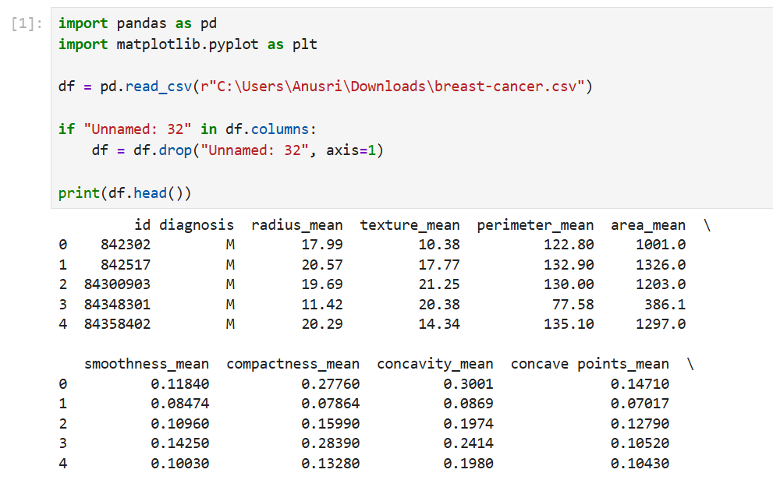

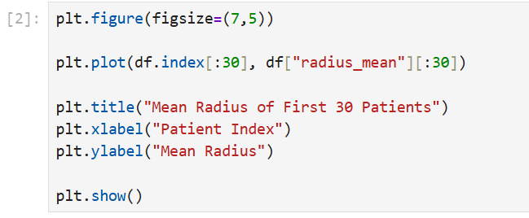
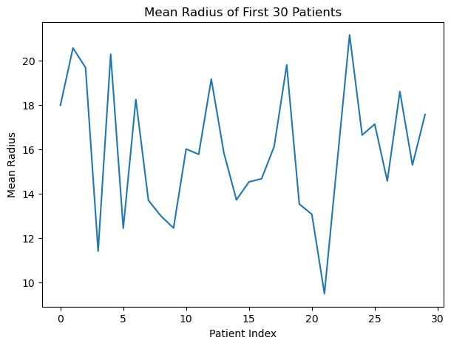
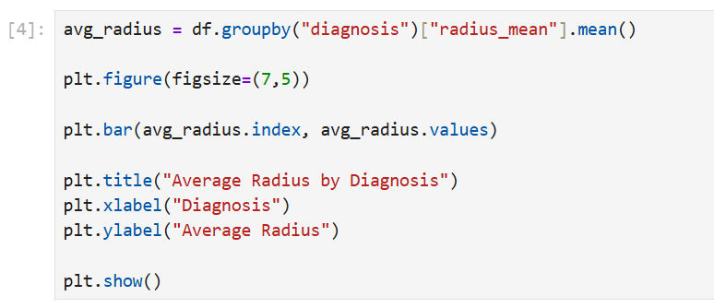
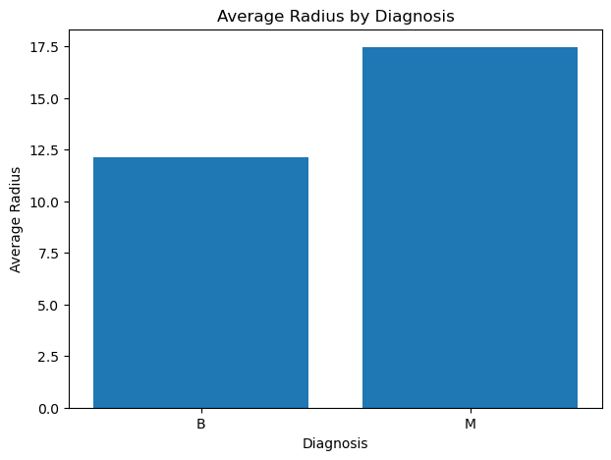
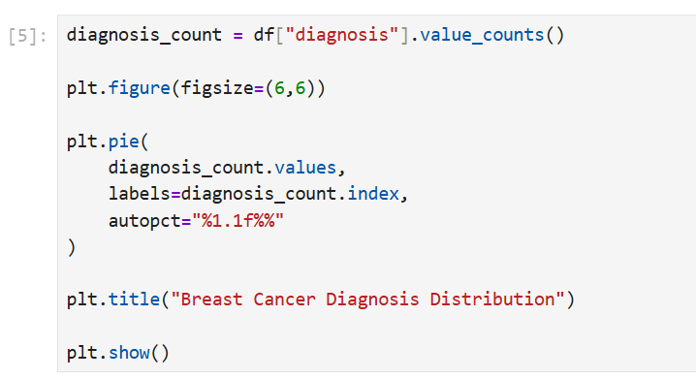
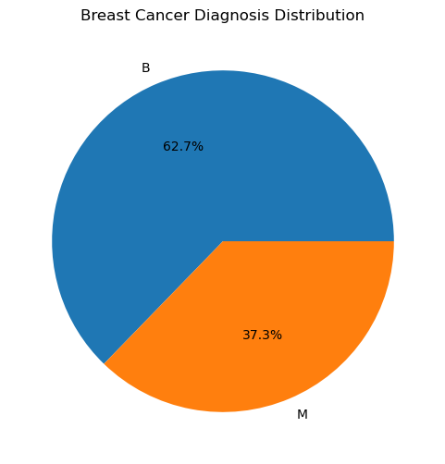
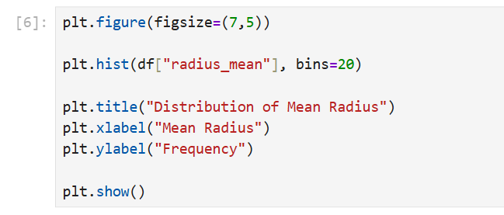
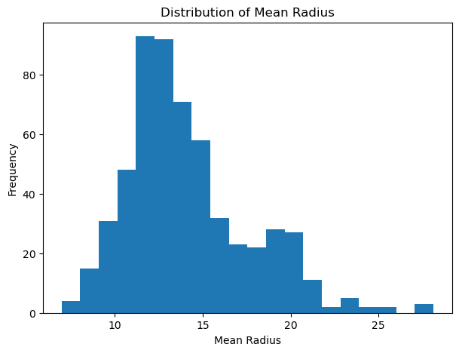
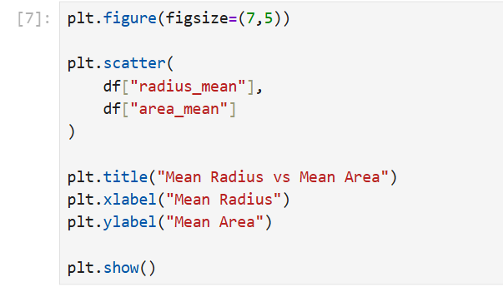
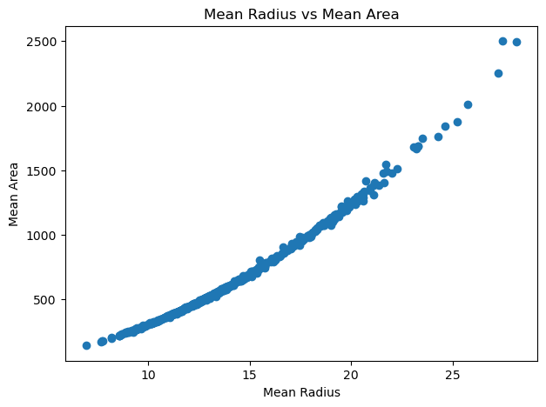
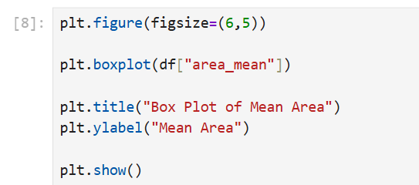
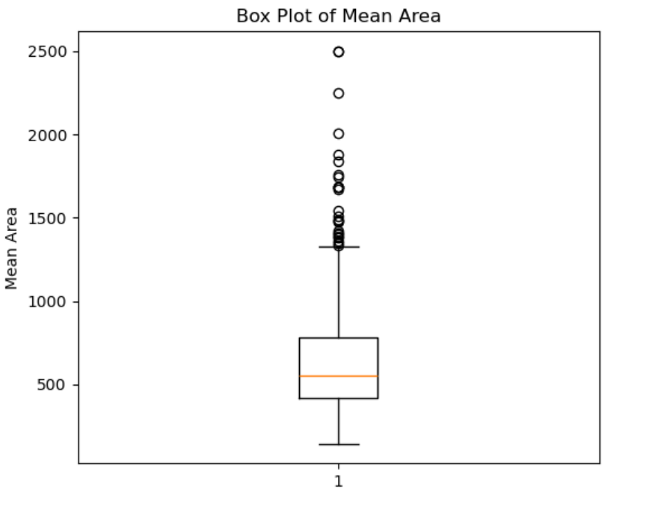
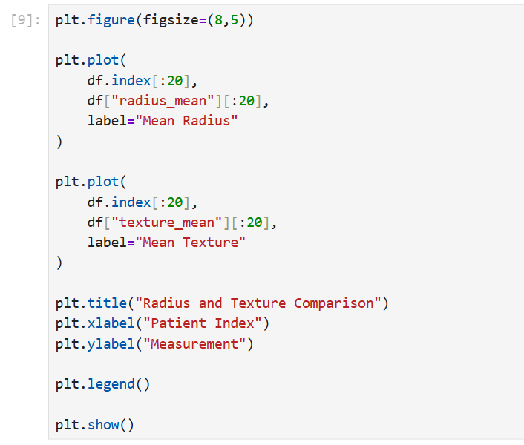

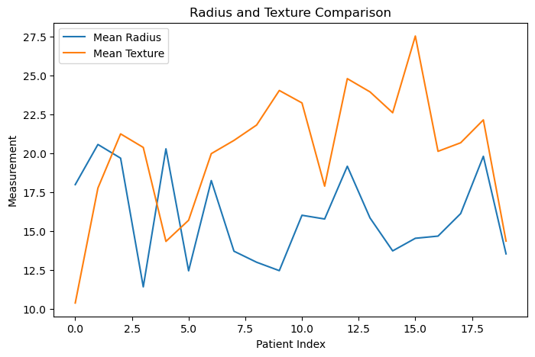

RESULT:
Thus, various visualization techniques such as Line Chart, Bar Chart, Pie Chart, Histogram, Scatter Plot, Box Plot, and Multiple Line Chart were successfully created using Matplotlib for the Breast Cancer dataset. The visualizations helped in understanding the distribution of diagnoses, comparison of benign and malignant cases, variation in measurements, relationships between features, and detection of possible outliers.

